The Top 10 Most Used High Level Programming Languages World Wide

According to the most recognizable studies and indexes, the following table shows the ranking of the most important high level programming languages recently:

|  |  |  |  |  |  |  |  |  |  |  |  |
| --- | --- | --- | --- | --- | --- | --- | --- | --- | --- | --- | --- |
| **#** | **Language** | **Tiobe Index** | | **in-Demand** | | **Pull Requests** | | **IEEE Index** | | **Totals** | **Ave.** |
| **1** | **Java** | 13.27% | 22.48% | 26,269 | 21.77% | 986,000 | 12.33% | 100 | 11.44% | **68.01%** | **17.00%** |
| **2** | **Java Script** | 2.47% | 4.18% | 24,248 | 20.09% | 2,300,000 | 28.76% | 84.3 | 9.64% | **62.67%** | **15.67%** |
| **3** | **Python** | 3.78% | 6.40% | 11,757 | 9.74% | 1,000,000 | 12.50% | 93.4 | 10.68% | **39.33%** | **9.83%** |
| **4** | **C** | 10.16% | 17.21% | 8,111 | 6.72% | 239,000 | 2.99% | 99.2 | 11.34% | **38.26%** | **9.57%** |
| **5** | **C++** | 4.72% | 7.99% | 8,584 | 7.11% | 413,000 | 5.16% | 95.5 | 10.92% | **31.19%** | **7.80%** |
| **6** | **C#** | 2.82% | 4.78% | 13,523 | 11.20% | 326,000 | 4.08% | 92.2 | 10.54% | **30.60%** | **7.65%** |
| **7** | **Ruby** | 1.42% | 2.41% | 4,417 | 3.66% | 870,000 | 10.88% | 78.6 | 8.99% | **25.93%** | **6.48%** |
| **8** | **PHP** | 1.59% | 2.69% | 4,971 | 4.12% | 559,000 | 6.99% | 84.6 | 9.68% | **23.48%** | **5.87%** |
| **9** | **R** | 1.91% | 3.24% | 1,599 | 1.32% |  |  | 74 | 8.46% | **13.02%** | **3.26%** |
| **10** | **MATLAB** | 1.57% | 2.66% | 789 | 0.65% |  |  | 72.6 | 8.30% | **11.62%** | **2.90%** |
| **11** | **Go** | 1.39% | 2.35% | 4,038 | 3.35% | 285,000 | 3.56% |  |  | **9.26%** | **2.32%** |
| **12** | **Swift** | 1.57% | 2.66% | 1,510 | 1.25% | 107,000 | 1.34% |  |  | **5.25%** | **1.31%** |
| **13** | **Perl** | 1.44% | 2.44% | 3,243 | 2.69% |  |  |  |  | **5.13%** | **1.28%** |
| **14** | **Objective-C** | 1.50% | 2.54% | 1,730 | 1.43% | 66,000 | 0.83% |  |  | **4.80%** | **1.20%** |
| **15** | **CSS** |  |  |  |  | 335,000 | 4.19% |  |  | **4.19%** | **1.05%** |
| **16** | **VB.NET** | 2.47% | 4.18% |  |  |  |  |  |  | **4.18%** | **1.05%** |
| **17** | **Scratch** | 1.37% | 2.32% | 700 | 0.58% |  |  |  |  | **2.90%** | **0.73%** |
| **18** | **Scala** |  |  | 1,827 | 1.51% | 99,000 | 1.24% |  |  | **2.75%** | **0.69%** |
| **19** | **Typescript** |  |  |  |  | 207,000 | 2.59% |  |  | **2.59%** | **0.65%** |
| **20** | **Shell** |  |  |  |  | 206,000 | 2.58% |  |  | **2.58%** | **0.64%** |
| **21** | **Assembly** | 1.47% | 2.49% |  |  |  |  |  |  | **2.49%** | **0.62%** |
| **22** | **Delphi** | 1.40% | 2.37% |  |  |  |  |  |  | **2.37%** | **0.59%** |
| **23** | **SQL** | 1.37% | 2.32% |  |  |  |  |  |  | **2.32%** | **0.58%** |
| **24** | **Visual Basic** | 1.35% | 2.29% |  |  |  |  |  |  | **2.29%** | **0.57%** |
| **25** | **Apex** |  |  | 1,609 | 1.33% |  |  |  |  | **1.33%** | **0.33%** |
| **26** | **SAS** |  |  | 975 | 0.81% |  |  |  |  | **0.81%** | **0.20%** |
| **27** | **Crystal** |  |  | 789 | 0.65% |  |  |  |  | **0.65%** | **0.16%** |

But if we want to have a very long term historical view, then the following table shows the positions of the top 10 programing languages of many years back. Please note that these are average positions for a period of 12 months:

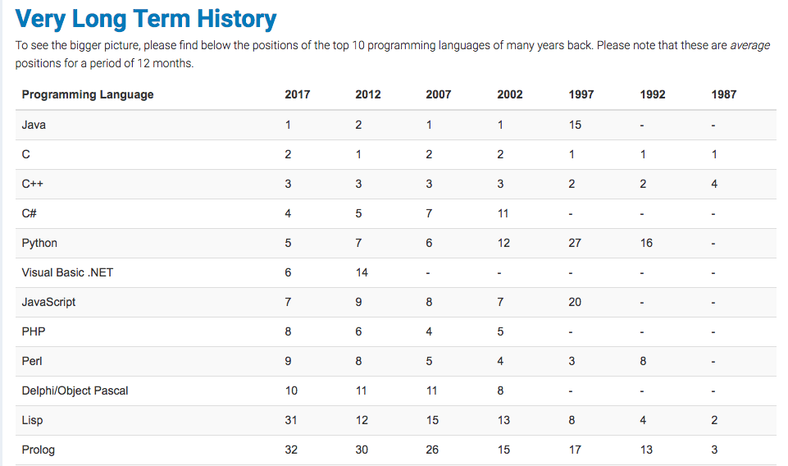

So, we can come to a fast conclusion about the top 10 programming languages as below:

1. Java.
2. Java Script.
3. Python.
4. C.
5. C++.
6. C#.
7. Ruby
8. PHP.
9. R.
10. MATLAB.

Features Comparison

1. Java.

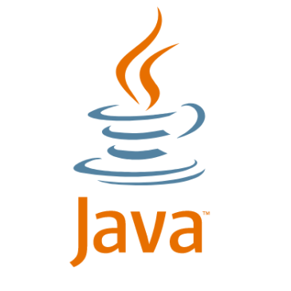

A list of most important features of Java language is given below.

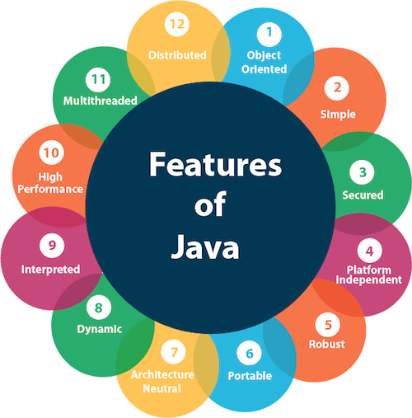

1. Simple
2. Object-Oriented
3. Portable
4. Platform independent
5. Secured
6. Robust
7. Architecture neutral
8. Interpreted
9. High Performance
10. Multithreaded
11. Distributed
12. Dynamic

In line with a slogan: Write Once, Run Anywhere, Java has become almost an omnipresent language that can be run virtually on any platform. This means that developers highly skilled in the language may be certain to find an interesting and well-paid job. salary ranging from $74,000 to **$130,000**

Java is top pick as one of the most popular programming languages, used for building server-side applications to video games and mobile apps. It's also the core foundation for developing Android apps, making it a favorite of many programmers. With its WORA mantra (write once, run anywhere), it's designed to be portable and run happily across multiple software platforms.

Java, a general purpose and object-oriented programming language, is used for creating server-side applications, video games, and mobile applications. As it’s the core element of any native Android application, Java keeps enjoying an enormous popularity among the developers.

[Java’s](https://en.wikipedia.org/wiki/Java_(programming_language))popularity is because of Android. Android is the most popular mobile OS and open-source. Java is a programming language and computing platform first released by Sun Microsystems in 1995. It’s a general-purpose programming language that is concurrent, class-based, object-oriented and specifically designed to have as few implementation dependencies as possible.

**Java is one of the most adopted programming languages, used by nine million developers and running on seven billion devices globally. It was designed to be a language that could run on any device and that is why it is used for software development for computers, smartphones, and even smart TVs.**

**The TIOBE programming community index places Java as no. 1, occupying a total of 20.79% from a list of 50 programming languages and it has known a 63% growth on GitHub by a number of pull requests in the last twelve months.**

**Java is the worldwide most popular language, according to the PYPL – PopularitY of Programming Language Index. Even though the tech community celebrated the twentieth anniversary of Java, this programming language will continue to dominate the job market in 2017.**

Java is one of the most practical languages to learn as it was designed to bypass the complexity of C++. It’s popularity cannot be overstated, as the majority (90%) of [Fortune 500](http://fortune.com/global500/list) companies use Java to develop backend systems and desktop apps. It’s highly portable as it boasts the cross platform compatible Java Virtual Machine (JVM).

Reinforces [Object-oriented principles](http://en.wikipedia.org/wiki/Object-oriented_programming) (OOP) used in modern languages including C++, Perl, Python, and PHP. Java is used mainly for creating server side apps, video games, and mobile apps. It’s the core of native Android apps and is enormously popular among developers.

Love it or hate it but you can’t ignore it. This line seems very suitable to [Java](http://codeforgeek.com/2014/07/java-mysql-connectivity-jdbc/)Programming language. Many developers around the global hate [Java](http://codeforgeek.com/2014/07/power-keyword-java/)due to it’s long syntax and complexity of codes. However, due to the magic of ‘**bytecode**‘ this language bypass the dependencies of platform and can be used at almost any computing platform.

Still if developer find a day when they don’t have to deal with java, this is how they feel.

1. Java Script.



JavaScript is a client side technology, it is mainly used for gives client side validation, but it have lot of features which are given below;

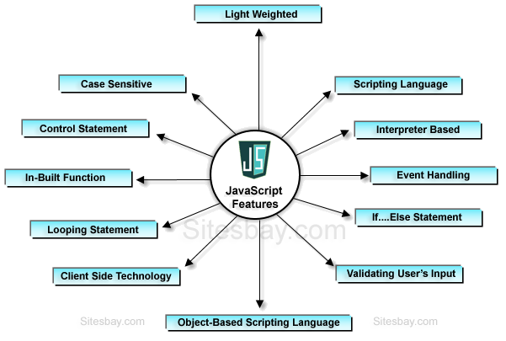

* JavaScript is a object-based scripting language.
* Giving the user more control over the browser.
* It Handling dates and time.
* It Detecting the user's browser and OS,
* It is light weighted.
* JavaScript is a scripting language and it is not java.
* JavaScript is interpreter based scripting language.
* JavaScript is case sensitive.
* JavaScript is object based language as it provides predefined objects.
* Every statement in javascript must be terminated with semicolon (;).
* Most of the javascript control statements syntax is same as syntax of control statements in C language.
* An important part of JavaScript is the ability to create new functions within scripts. Declare a function in JavaScript using **function** keyword.

**Limitations of JavaScript**

JavaScript have some limitation which are given below;

* Client-side JavaScript does not allow the reading or writing of files.
* It cannot be used for networking applications because there is no such support available.
* It doesn't have any multithreading or multiprocessor capabilities.
* [Giving the user more control over the browser](http://www.javascripter.net/faq/javascri.htm#no1)
* [Detecting the user's browser, OS, screen size, etc.](http://www.javascripter.net/faq/javascri.htm#no2)
* [Performing simple computations on the client side](http://www.javascripter.net/faq/javascri.htm#no3)
* [Validating the user's input](http://www.javascripter.net/faq/javascri.htm#no4)
* [Handling dates and time](http://www.javascripter.net/faq/javascri.htm#no5)
* [Generating HTML code on-the-fly without accessing the Web server](http://www.javascripter.net/faq/javascri.htm#no6).

JavaScript is a very popular language believed to be easy to learn. Programmers who know it will be still sought-after in the market as it is constantly in demand in many companies. average salary of **$92,000**

is another favorite programming language because it's so ubiquitous on the web--it's basically everywhere. JavaScript allows developers to add interactive elements to their website, and its presence is felt across the internet. At WordStream, we use a JavaScript library called [JQuery](http://jquery.com/) to make our JavaScript work even easier.

JavaScript, also known as the language of the web, is at the top as it’s basically everywhere. This is a high-level, dynamic, and interpreted programming language that’s supported by all modern web browsers. It allows the developers to build web applications and add interactive elements to the websites.

avaScript is the number one programming language that will rank in 2018. It’s a programming language that is run by most modern browsers. It supports object-oriented programming and procedural programming. Knowadays, you can use JavaScript to build mobile app, web app and even desktop applications. ES6 or ES2015 is the latest version of this language. The ES6 features are amazing and blow your mind.

**JavaScript is a high-level and dynamic programming language, considered one of the world’s most powerful and popular languages, used to spice up the web pages by making them interactive. With JavaScript, you can display pop-up messages, add effects to the web pages or develop games with the basic functionality.**

**Programming experts know that JavaScript has been at the top of the list on the TIOBE index for a few years, at this moment ranking 7th in the list of 50 programming languages.**

JavaScript is client end scripting language developed by Netscape. JavaScript is becoming popular day by day in Web development zone and since the invention of [Node](http://codeforgeek.com/2014/09/manage-session-using-node-js-express-4/), it is something you should learn ASAP. Some of popular Libraries such as [jQuery](http://codeforgeek.com/2014/07/node-email-verification-script/), [angularJS](http://codeforgeek.com/2014/08/ajax-live-search-angular-node/" \o "Ajax Live Search Using Angular and Node" \t "_blank)and [NodeJS](http://codeforgeek.com/2014/09/ajax-search-box-using-node-mysql/" \o "Ajax Search Box Using Node and MySQL" \t "_blank)pull up the JavaScript at 7th position of top 10 programming languages.

It came up as the most used programming by developers, at 62.5%, as taken in the [Stack Overflow Developer Survey](http://stackoverflow.com/research/developer-survey-2016), which surveryed over 64,000 developers in 173 countries. It allows you to build interactive websites, and is truly an essential web tool technology, alongside HTML and CSS, because most browsers in some way implement JavaScript. It’s crucial for getting into web development, and learning this language paves the way for front end development and back end development. It might not be as useful as Python or Java, but it’s generally easier to pick and do something tangible with, in part because of all of the accessible UI features.

For making interactive things for the web, Javascript is to go, you’ll see immediate results from your coding efforts with little tools. Adding on to this, Javascript usage has extended to include mobile app development, game development, and desktop app development. It’s definitely exploded in popularity, and is definitely one of the best programming languages out there.

1. Python.

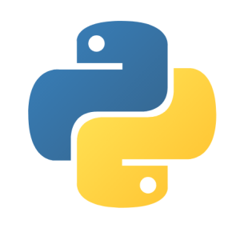

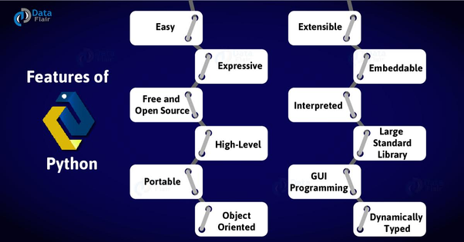

It is a versatile and clear language, used by the big players in the technology industry (Google, NASA). around the amount of **$105,000** and higher.

Python is beautiful scripting language that has evolved to support developer ecosystems in many fields. It offers Django and Flask, making it simple to build web applications and APIs. The community also offers incredibly robust tools for data science and academic programming.

Python is a one-stop shop. There's a Python framework for pretty much anything, from web apps to data analysis. In fact, WordStream is written in Python! You're the best bud. Python is often heralded as the easiest programming language to learn, with its simple and straightforward syntax.

Python is a widely popular and general purpose programming language. Just think about the job and a Python framework is there for you. Due to its simple syntax, it’s also recommended as the first programming language. Without a doubt, Python is one of the best popular programming languages you can run in 2017.

Python is one of the most powerful programming languages of all the time. It’s a widely used high-level programming language for general-purpose programming, created by Guido van Rossum. The applications like Youtube, Dropbox and Google is based on this language. If you want to work for Google, This language is what you should focus on.

**Python is a widely used high-level, general-purpose and dynamic programming language. It’s “the” language of the moment and the chosen starter language in university courses around the world. It has the biggest year-on-year job demand growth of any language, stated by the Stone River Academy.**

**Python worldwide has grown the most in the last 5 years (7.0%), following Java in popularity, as stated by PYPL.**

Python is rich, general purpose, high level programming language which supports multiple programming paradigms such as procedural,object oriented. What i mean by rich is that, python has so many libraries already built up which speed up your development process.

Python is used in research area a lot, some of the popular web projects such as YouTube (entirely on Python), Google (some part on python) using python.

Python has very popular web framework called ‘**django**‘ which makes python tough competitor to other web frameworks.

1. C.



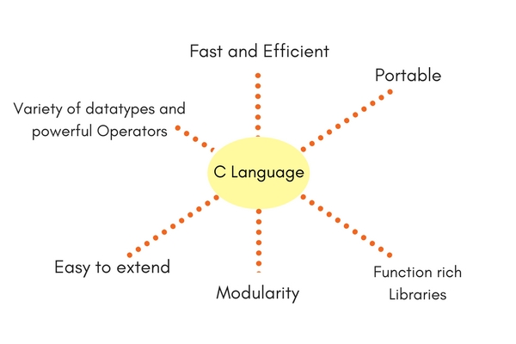

**Features of C Programming Language :**

| **Features of C** |  |
| --- | --- |
| Low Level Language Support | Program Portability |
| Powerful and Feature Rich | Bit Manipulation |
| High Level Features | Modular Programming |
| Efficient Use of Pointers |  |

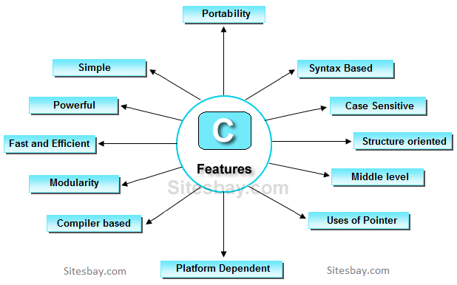

C is the basis for many other programming languages, and even if programmers themselves argue whether it is still needed, companies seem to constantly see its potential. For many people, the C language is the basis of modern computing, and is extremely useful. they will exceed **$100,000** annually.

If you saw C on a report card, you'd be pretty bummed. Maybe a bit confused, too (is it actually a B-?). However, C is not the bizarrely bad grade it seems to be. It's often the first programming language taught in college (well, it was for me 10 years ago). I thought it was a nice "in-between" language in that it was object oriented without having to be fanatical about it. It was also low level enough to be close to hardware, but no so low level that you had to do everything manually. Because there are so many C compilers, you can write stuff in C and have it run pretty much anywhere.

C is the predecessor to more complex programming languages like Java and C#. C is best when you want to work small and when dealing with low-level applications. It's widely used for embedded systems like the firmware of your television or the operating system of an airplane, as well as computer operating systems like Windows.

C is taught still in most popular universities in the world. It’s not a high-level programming language, but people learn it because it makes learning other languages easier. High-level languages like Java, C++, C# are almost similar. It’s like the older version of C++. This language is used a lot in embedded hardware programming where resources are scarce. Linux kernel is written in C.

Established in 1972 to enable programmers to write in the UNIX operating system, it still proves very, very popular. It’s one of the most widely used programming languages in the world. And because it operates as at a ‘machine level’ language’ you’ll be able to learn how a program interacts with hardware. Not only is it one of the most stable languages, it works on nearly all computing platforms.

Dropbox, eBay, and Spotify all use C programming, and the entirety of the Linux OS is written using C language.

C is one of the first high level programming language. C is powerful, robust, foundation of many popular programming language such as C++, Java etc. C is developed by Dennis Ritchie in At & T labs. It was built on a time when Normal people need to understand what is the computer first before jumping to something called ‘**programming**‘.

I think the reason why it is on second position is due to the less support to the web. Well we all know ‘**Web**‘ is the future.

1. C++.

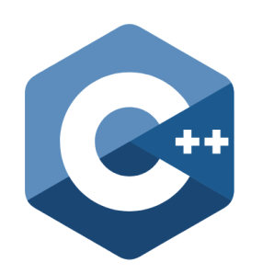

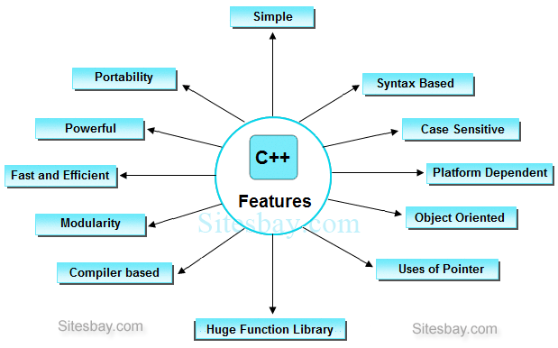

Cpp Features

If you want to be called a professional developer, you certainly need to know the language. C++ is best known as an efficient and flexible language used for the creation of large systems, such as desktop applications and server platforms. It is very popular and reliable. It is considered one of the best solutions for creating applications that process music and film. will reach at least **$102,000** per year.

Based on C, C++ is a general purpose programming language that has influenced many other modern programming languages. Tons of daily applications, software, drivers, firmware, etc., used by us are written in C++. It’s considered to be an intermediate level language that has the qualities of both high-level and low-level programming language.

Most other top programming languages are based on C++. They have copied the style and structure from C++. For instance, Java, C#, JavaScript and more. C++ is a general-purpose object-oriented programming (OOP) language, developed by Bjarne Stroustrup. You can use this powerful language to build applications that run on CPU, build mobile apps, games, and desktop application.

 It was created in 1983 as an alternative to C, and instantly gained popularity, for good reason. It features predefined classes that can be used alongside classes a programmer may already be using. Microsoft Windows and Google Chrome are two of the most well known projects created with C++, and indeed, most of Adobe, and much of Amazon’s websites are written in C++. This programming language has remained in demand because it is a powerful tool that is adaptable in a variety of sectors, including Finance, Banking, Games, Telecoms, Electronic Banking, Retail, and more.

Indeed, learning C++ enables you to code apps as well as games and commercial software with ease. It’s one of the most powerful languages out there, and hosts a variety of features, including being platform dependent, (i.e. the program is executed in the same operating system in which it was developed).

C++ is a ‘**C with classes**‘. It’s very powerful object oriented programming language developed as successor of C. It is widely used in ‘**Game programming**‘ and various areas. It is secured as third position on top 10 programming languages list. It deserve to be so !

1. C#.

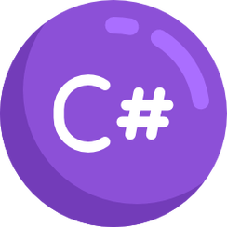

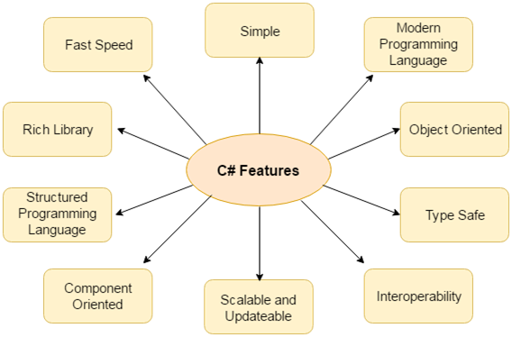

C# is known for its simplicity and widespread use. the average salary of a developer specialising in the object-oriented language will amount to **$89,000.**

is the language used in order to develop Microsoft apps. C# is syntactically nearly identical to Java. I've spent much time training with C#, but if you're good at Java, you'll likely have an easy time jumping onto C#. If you're looking to work on Microsoft apps, C# is the way to go. C# opens a lot of Windows(har-har).

Designed by Microsoft, C# (pronounced C-sharp) is a general-purpose, modern, object-oriented programming language. This relatively newer language breathes life into a wide range of Microsoft applications that are powered by .NET Framework. The programming in C# is very much based on C and C++. So, if you have a basic idea of C and C++, learning C# won’t be much tough.

Microsoft, of course, the biggest company in the technology category. Their primary language is C#. It’s used for developing desktop, mobile, and games in Unity. It’s a multi-paradigm programming language encompassing strong typing, imperative, declarative, functional, generic, object-oriented (class-based), and component-oriented programming disciplines.

**Dating since 2000, C# is a new programming language designed by Microsoft for a wide range of enterprise applications that run on the .NET Framework. Still in the shadows of PHP and Java, C# has experienced a growing popularity every year.**

**As an evolution of C and C++, this language is simple modern, object-orientated and functional.**

Designed by Microsoft, this general purpose, multi paradigm programming language was used for developing apps on the Microsoft platform. C# operates as a general purpose, object oriented programming language. It works for apps powered by .NET frameworks. So, if that’s your market, C# is the best language to use for building apps native to the Microsoft platform, and is further the recommended language for developing games using the Unity Game engine.

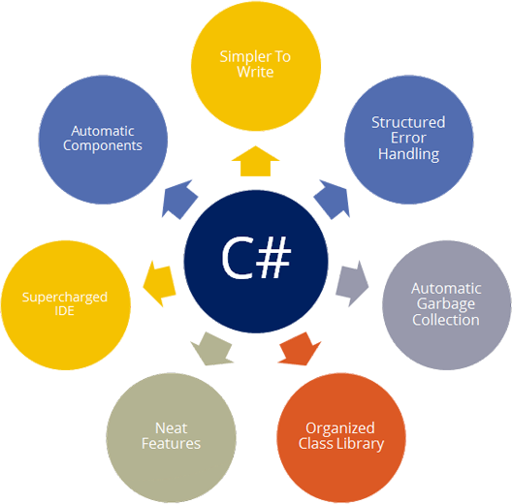

It was designed with simplicity and ease of use as a priority, and because it’s a high level language it reads closer to English. As a language, C# abstracts the complex details of the computer so you as the developer can focus on programming instead of worrying about the little details.

You can make anything in C#, from web services to mobile apps, server applications and more. Whilst experts contend that demand for C# is dipping, [Xamarin](https://www.xamarin.com/platform" \t "_blank) changes those expectations, as the platform makes creating apps for Android and iOS much simpler.

C# is high level programming language developed by Microsoft. It comes under .NET framework. C# is general purpose, rich and supports various computing devices. It is widely used in Application development.

1. Ruby.

Ruby language has many features. Some of them are explained below:

* Object-oriented
* Flexibility
* Expressive feature
* Mixins
* Visual appearance
* Dynamic typing and Duck typing
* Exception handling
* Garbage collector
* Portable
* Keywords
* Statement delimiters
* Variable constants
* Naming conventions
* Keyword arguments
* Method names
* Singleton methods
* Missing method
* Case Sensitive

## Features of Ruby

* Ruby is an open-source and is freely available on the Web, but it is subject to a license.
* Ruby is a general-purpose, interpreted programming language.
* Ruby is a true object-oriented programming language.
* Ruby is a server-side scripting language similar to Python and PERL.
* Ruby can be used to write Common Gateway Interface (CGI) scripts.
* Ruby can be embedded into Hypertext Markup Language (HTML).
* Ruby has a clean and easy syntax that allows a new developer to learn very quickly and easily.
* Ruby has similar syntax to that of many programming languages such as C++ and Perl.
* Ruby is very much scalable and big programs written in Ruby are easily maintainable.
* Ruby can be used for developing Internet and intranet applications.
* Ruby can be installed in Windows and POSIX environments.
* Ruby support many GUI tools such as Tcl/Tk, GTK, and OpenGL.
* Ruby can easily be connected to DB2, MySQL, Oracle, and Sybase.
* Ruby has a rich set of built-in functions, which can be used directly into Ruby scripts.

Ruby (also known as Ruby on Rails) is a major supplier of web apps. Ruby is popular due to its ease of learning (it's very straightforward) and power. Ruby knowledge is in high demand these days!

Ruby, a general purpose and object oriented programming language, supports multiple programming paradigms and is used to create web apps. Apart from being easy to use, Ruby is known for its power. Ruby on Rails (Rails is a framework) is in high demand these days.

**Ranking no. 10 in the TIOBE index, Ruby is a general-purpose programming language, best known for its use in web programming, Rails serving as the framework for the Ruby language.**

**Ruby is a favorite among developers, startups, and established businesses with many qualities as fast development, fewer lines of code to write, a broad variety of third-party libraries available and a thriving community support and expected constant improvements in the code.**

A general purpose, object oriented programming language born in the 1993 by Yukihiro Matz Matsumoto. It’s 5 times more in demand than Python, and one of the fastest growing programming languages, seen only to Java for the most projects completed. In fact, Ruby is so easy to use you can create an app in it in under 10 minutes. Groupon, Airbnb, Pxlr, and Bloomberg are all coded in Ruby, as well as many more.

Ruby operates as a dynamic, object orientated, because it reads like English, it makes the code easy to read. It’s needed to maintain code databases for many high end websites, so Ruby’s demand is increasing, so much so that it’s become common within DevOps roles, i.e. the engineers ensuring the reliability and efficiency of the servers running websites with high traffic. Depending on your company’s needs, this could be the one for you.

Ruby is Object oriented, dynamic programming language. It is used by many research organisation. Ruby on rails is one of the popular web framework. [Twitter](http://codeforgeek.com/2014/09/twitter-login-using-node/) use this framework.

1. PHP.

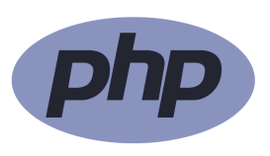

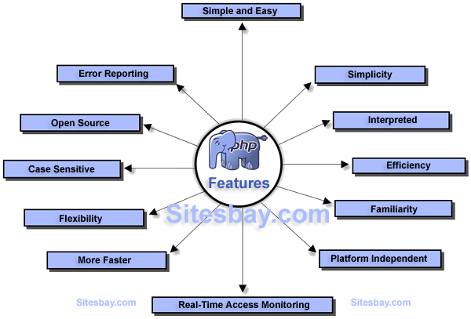

### Features of php

It is most popular and frequently used world wide scripting language, the main reason of popularity is; It is open source and very simple.

* Simple
* Faster
* Interpreted
* Open Source
* Case Sensitive
* Simplicity
* Efficiency
* Platform Independent
* Security
* Flexibility
* Familiarity
* Error Reporting
* Loosely Typed Language
* Real-Time Access Monitoring

PHP (which stands for Hypertext Preprocessor, if you care to know) is often used in conjunction with dynamic data-heavy websites and app development. It provides a ton of power and is the beating heart of monster sites like WordPress and Facebook. What's really cool about PHP is that it's an open-source language, so there are tons of free pre-built modules that you can grab and modify to get your ideal results. PHP is also on the easy end of the learning spectrum, simply requiring you to embed the code within HTML. PHP is a must-learn language for aspiring web developers.

PHP is a server-side scripting language that primarily focused on web development. It forms the base of two internet giants, WordPress and Facebook. If you wish to become a web developer, PHP is an important language that you need to learn.

Becuase web programming is popular category among other desktops, mobile, and CPU, PHP remains the most popular server side programming language. It’s a general-purpose scripting language that is especially suited to server-side web development, in which case PHP runs on a web server. The application like WordPress, Joomla, Drupal, and Facebook is written in PHP.

**PHP is the most popular language used to write various web applications, having a more significant edge over its competitors as it is open source and stable. PHP is ranked 6th in the TIOBE programming community index and has grown with 43% on GitHub by a number of pull requests in the last twelve months.**

**Most recruiters over the world look for PHP developers to build dynamic websites which are responsive and interactive as well.**

**PHP**is widely used thanks to Wordpress. 80% of the top 10 million websites use PHP in some sort of way, including Facebook and Wikipedia. There are no hard rules on how to build features, and it boasts flexibility in solving problems. It’s further used widely in a freelance capacity or for popular content management systems. It’s a great choice for web development as it’s mainly a server side scripting language, forming the base of both Wordpress and Facebook. So for web development, learning PHP is mandatory for success. Learning PHP puts you in the position to create stunning, dynamic websites and web applications. You can use PHP for various web development projects, including ecommerce, mobile app development, content management system. It’s an open source, easy to learn, with an easy data base integration and has numerous applications and uses.

[PHP](http://codeforgeek.com/2014/09/ajax-search-box-php-mysql/)is high level interpreted programming language developed for web projects. It is widely used in Web development. If IEEE consider only Web to be the matric then i am confident that [PHP](http://codeforgeek.com/2014/08/session-handling-php/)would be at position 1.

Some of the popular web projects such as [**Facebook**](http://codeforgeek.com/2014/06/facebook-status-box-using-node-js-expressjs-mysql/)uses PHP as core language. [PHP](http://codeforgeek.com/2014/07/php-mysql-connectivity/)supports Object oriented paradigm as well. It is rank as 6th among top 10 programming languages.

1. R.



## R Programming Features

[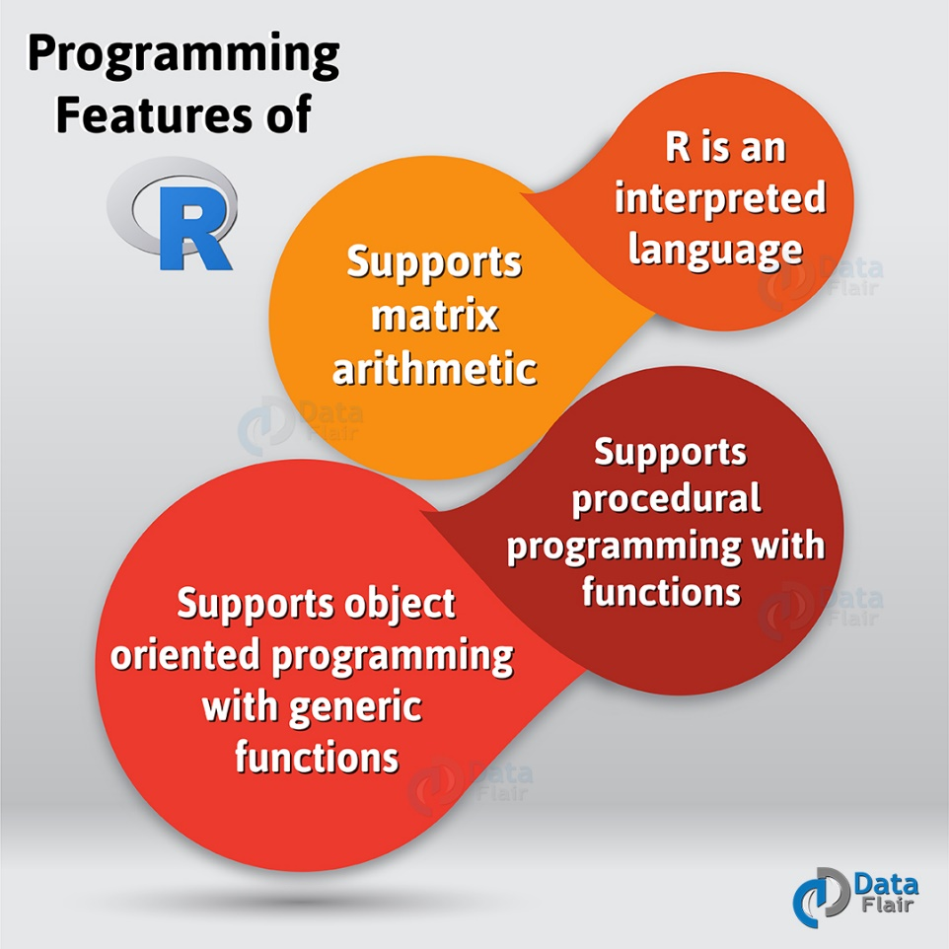](https://d2h0cx97tjks2p.cloudfront.net/blogs/wp-content/uploads/Programming-features-of-R-01-1.jpg)

*Introduction to R Programming – Features of R Programming*

* R supports procedural programming with functions and [**object-oriented programming**](http://data-flair.training/blogs/object-oriented-programming-in-r/) with  
  generic functions. Procedural programming includes procedure, records, modules, and  
  procedure calls. While object-oriented programming language includes class, objects, and  
  functions.
* [**Packages**](http://data-flair.training/blogs/r-packages-tutorial/)are part of R programming. Hence, they are useful in collecting sets of [**R functions**](http://data-flair.training/blogs/r-programming-functions/)into a single unit.
* Rs programming features include database input, exporting data, viewing data, variable labels, missing data, etc.
* R is an interpreted language. So we can access it through command line interpreter.
* R supports [**matrix**](http://data-flair.training/blogs/r-matrices-operations-applications/)arithmetic.
* It has effective data handling and storage facilities.
* It supports a large pool of operators for performing operations on arrays and matrices.
* It has facilities to print the reports for the analysis performed in the form of graphs either on-screen or on hardcopy.

You can obtain the installation files for the R program on the official R Website (www.r-project.org). The website has general documentation related to R along with the libraries of routines. The R program can be simply downloaded and installed from the R Website.

The R (GNU S) language is used most frequently in advanced statistical calculations. the annual remuneration of **$99,000**.

R is a programming language and software environment for statistical analysis, graphics representation, and reporting. R is a very flexible tool for doing a mathematical & statistical analysis. If you are dealing with big data, R is the language you must use. It’s easily extendable via packages.

R is statistical programming language designed for doing analysis on large amount of data. Most of the ‘**Machine Learning**‘ experiments used to perform on R programming language. Since it’s not general purpose language and not used widely it is rank at 9th position of top 10 programming languages.

1. MATLAB.

Matlab is programming language with rich set of libraries to perform image processing, analysis and enhancement. it is widely used in image processing area. It is one of the tough languages i found to learn. Yes tougher than Java !

* Dealing with Matrices and Arrays
* 2-D and 3-D Plotting and graphics
* Linear Algebra
* Algebraic Equations
* Non-linear Functions
* Statistics
* Data Analysis
* Calculus and Differential Equations
* Numerical Calculations
* Integration
* Transforms
* Curve Fitting
* Various other special functions

1. GO.

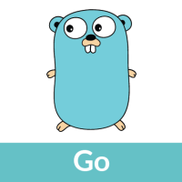

Go is simply taking over the programming world. The language was created by Google in 2009 and offers many of the benefits of C/C++, but Go makes many changes to improve brevity, simplicity, and safety. Simply stated, Go does practically everything well. The code is easy to understand but also incredibly efficient computationally. A new developer can pick it up rather quickly. It is a statically typed and compiled language that manages concurrency efficiently.

Go is an open source programming language that’s aimed at making simple, efficient, and reliable software. It was created by three Google employees in 2007. In the recent times, it has emerged as one of the most popular programming languages, and it’s used by some of the Google’s won production systems. Many Go projects are also used for web servers, APIs, minimal web application frameworks, etc.

Go (often referred to as golang) is a free and open source programming language created at Google in 2007 by Robert Griesemer, Rob Pike, and Ken Thompson. It’s compiled and has features such as garbage collection, memory safety, and limited structural typing. Go is good for Stand-alone command-line apps or scripts Network and Web servers. It’s not good for desktop, system-level programming, and  GUI-based apps

**Go is a free and open source programming language created by Google in 2007. In 2016 its popularity skyrocketed because it emphasizes simplicity, high performance, efficiency and built-in support.**

**Keeping in mind that many start-ups have made it their language of choice, 2017 is guaranteed to be the year when more developers start using Go.**